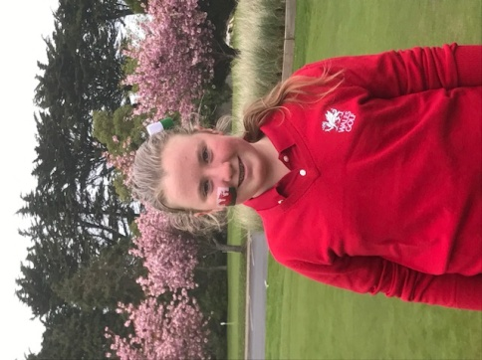**WALES GOLF PLAYER BIOGRAPHY**

**Full Name:** Harriet Elizabeth Lockley

**Club:**Isle of Wedmore GC and Burnham and Berrow GC

**Handicap:**4 (3.7)

**Age:**12 (Teenager in January 2018)

**How did you become interested in playing golf?**

I have always been at the Golf Club, as both my Mum and Dad play lots of golf. I started hitting balls when I was 5 and I loved it so I started pestering Dad to take me to the range.

**At what age did you begin playing competitively?**

I played in my first Wee Wonders competition when I was 8, and qualified to play at St. Andrews!

**What is your most memorable golf experience or moment?**

My most memorable moment in golf was my first tee shot when playing for Wales against Ireland – I was so nervous but it was such great fun. Once it was complete I wanted to do it again and again!

**What is your favourite golf course and why?**

Easy one – Pennard GC Best holes and best views anywhere. Any course that has a castle in it, must be good!!

**Who is your favourite golfer and why?**

Laura Davis – she hits it massive and has won everything. She also signed my golf ball when I was 8!

**Who is the most influential person in your life?**

My Mum – she takes me everywhere, is a great person, is a good golfer (ish) and helps me in everything I do.

**What three words would you use to describe you?**

Dedicated

Stubborn

Happy

**Where do you see yourself in 5 years from now?**

I hope to be playing golf regularly for Wales, winning national trophies and planning on going toUniversity at either St. Andrews or in the US. My handicap will be plus something and I will be incredibly happy.

I will also be 5 foot 8 inches tall!

**Any honours, awards, and achievements in golf that you would like to share:**

My top 5 golfing achievements are:

1. Being ranked #1 in European rankings at U12 level (2017)
2. Playing for Wales twice at U14 level (2016, 2017)
3. Playing for Somerset County Ladies (2017)
4. Winning the British U12 Championships 2016 (Wee Wonders)and US Kids European Championships U11 2016
5. Winning the Welsh Girls Championship Plate Competition (2017)