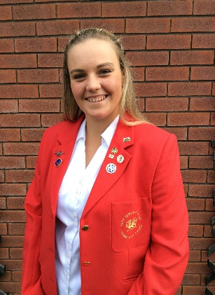

WALES GOLF PLAYER BIOGRAPHY

Full Name:Lea-Anne Bramwell

Club: Abergele, Wrexham and Conwy

Handicap: 2

Age: 17

How did you become interested in playing golf?
Dad had played for years and my mum and sister started so I thought ‘Why not have a go’, I was hooked straight away!

At what age did you begin playing competitively?
11

What is your most memorable golf experience or moment?
Irish Girls Championships 2017, leading the field into the last round and playing in the final group! The crowd of people on the last hole! #Nervous

What is your favourite golf course and why?
Rowganstown Golf and country Club, Dublin. Home of the Irish Girls Championships. Brilliant memories (see above) and the course suites my game.

Who is your favourite golfer and why?
Amy Boulden. Amy is from North Wales like me. We have the same coach (Paul Williams) and Amy has gone through the Wales Golf system. By following in Amy’s footsteps it is possible to see my dream of playing on the LET is within reach and not just a dream!

Who is the most influential person in your life?
Sorry, got to be 2 people! Mum and Dad. They are a massive part of my life and golfing career. They have always believed in me and when Paul saw something in me and offered to coach me we have gone from strength to strength. We work as a team - Dad helps with my golf training alongside Paul and mum sorts out my schedule of comps, booking hotels etc and taking me all over the country. I really would not be where I am today and where I am going to be in the near future without their support!!
What three words would you use to describe you?
Committed, Competitive and Focused
Where do you see yourself in 5 years from now?
Making a living from golf playing on the Ladies European Tour.

Any honours, awards, and achievements in golf that you would like to share:
Mini Masters Champion 2012 County Champion
County Schools Champion Wales Schools Champion
County Order of Merit Winner Club Champion 3 years running
Represented Wales inHome Internationals and British Open
Top 10 in Junior European Open in Spain 2 years running.

