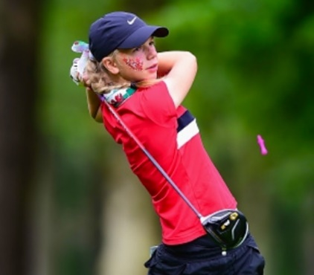
WALES GOLF PLAYER BIOGRAPHY

Full name:Ffion Elizabeth Vineall

Club: Newport

Handicap: 3.6

Age: 16

How did you become interested in golf?
Golf was always in my family – my grandad, cousins and brother all played so I joined in with them.

At what age did you begin playing competitively?
9 years old. My first competition was a 9 hole comp at Dewstow Golf Club.

What is your most memorable golf experience or moment?
It was at Conwy in my first Homes on the final day vs England. I hadn’t won any points so far and I was 4 down after 13 so it wasn’t looking very promising! However, I managed to get it back to all square going down 18 and I had a 3foot putt for par and to halve the match. I had always had a thing over short putts, so this was my worst nightmare. There was a massive crowd of people watching me and I don’t think I have ever been so nervous in my life! Thankfully I made the putt and halved the match. It was amazing to get my first points on the board for Wales and is a moment that I will always remember.

What is your favourite golf course and why?
Royal Cromer- it was where I played the English girls U14 championship when I was 14 and I loved the course. It is a mix of parkland and links and a good test, especially when the wind is up! It was in great condition and had some really spectacular views.

Who is your favourite golfer and why?
Anna Nordqvist- I remember watching her in the Solheim Cup in 2015 and being inspired by her. She always comes across as in control of her emotions, is determined in her approach and all aspects of her game are strong.

Who is the most influential person in your life?
My parents- they give me so much support, driving me all around the country and always helping me to become the best person I can be.

What three words would you use to describe yourself?
Determined, conscientious, ‘blonde’

Where do you see yourself in five years from now?
Having graduated from a Division 1 American university with a degree in business with Spanish and playing amateur golf to a high level, seeing where my golf can take me.

Any honours, awards, and achievements in golf that you would like to share?

Welsh Girls U16 champion 2016
T5 in Scottish girls U16 championship 2017
Wales Girls Home Internationals Team 2016 and 17
T21 English girls u18 championship 2017
  - 2nd in Welsh girls order of merit 2016

