Annual Report 2017/18

Chairman’s Report

At the Golf Union of Wales AGM last September the brand “Wales Golf” was launched. As part of the re-branding process Golf Development Wales and the Golf Union of Wales unite under a fresh new identity to coincide with the launch of our new 5-year Strategic Plan.

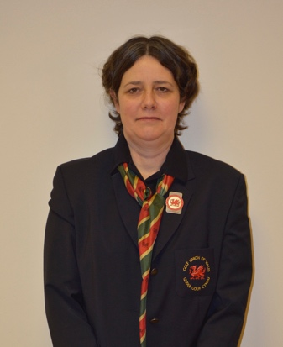
Our vision is to make Golf “Everyone’s Game. Anywhere’. We will create and support an environment in Wales where golf is safe and accessible for everyone to participate, enjoy and progress. We have two versions of our strategy - a summary one page document and a twelve page more detailed document, both are available for download from our website www.walesgolf.org.

It is just over 10 years since the Welsh Golfing Union and Welsh Ladies Golf Union became the first of the Home Unions to merge so now is the perfect time to launch a fresh new identity to coincide with a new Strategic Plan 2018-2022. This had led to a much clearer understanding by our partners, members and golfers in general of how we are structured with GDW being fully integrated within Wales Golf with one set of clearly articulated strategic objectives.

On a more practical front the re-branding exercise has come with some restructuring resulting in a re-alignment of departments/cost centres i.e. Development, Championship & Rules, Elite Performance and Golf Course (incorporating Handicapping & Course Rating). It has in turn created a number of administrative efficiencies such as one website, one set of accounts one AGM etc

The financial challenges the game faces are still apparent to Wales Golf and demonstrates the ongoing need for prudent financial management to enable us to deliver the best possible outcomes for golf whilst balancing the budget. We are grateful for the on-going support of Sports Wales, the R&A, PGA, Golf Foundation and all our sponsors. Subscriptions also make a significant contribution to the overall budget and we are well aware that we must provide value for money for everyone.

A National Governing Body Early Adopter scheme to help shape how Sport Wales will work with Governing bodies in the future was launched late in 2017. This model covers three areas – Strategy, Key Performance Indicators and Collaboration and Governance. Golf was the only sport accepted for all three areas and scored the highest on the application criteria. We are looking forward to sharing our insights and learning from other governing bodies whilst helping shape the future of sport in Wales.

Following the LGU and R&A Merger at the start of 2017 as part of the initiative to encourage greater female participation in golf the R&A have awarded Wales Golf funding to recruit a Women and Girls Coordinator to help us develop this focus area. Simon Lu has focused on taking Women and Girls development to another level. We have signed up to the Women and Girls Charter launched by the R&A in May and published our charter.

It is now widely known that a Worldwide Handicapping System will be introduced in 2020, this groundbreaking initiative is being led by the R&A and USGA and is fully supported by Wales Golf. We will be working closely with CONGU, the R&A and the USGA on the transition towards implementation of the new system. Workshops are scheduled for autumn 2018 to explain the new system and implications going forward. These workshops will be run in conjunction with the Championships team to explain Rules Modernisation which launches in 2019. We have employed a new Golf Coordinator, Sandy Veale, this post replaces that of Dan Farmer who left to work at Sports Wales and the post will provide support to the Championships team and the new Golf Course department which will oversee Handicapping & Course Rating.

The support for clubs and Welsh Golf being linked to our key performance indicators (KPIs) enables us to make maximum use of our resources, staff and volunteers in providing a comprehensive range of schemes, resources, events and workshops which are reported elsewhere. The Club Governance matrix continues to be well received and is providing support for your club to develop.

Our roadshows provide us with an opportunity to interact with clubs whilst providing updates and support on a variety of topics - Rules Modernisation, Worldwide Handicapping, Health and Wellbeing of the Sport and participation in the game by promoting new formats alongside the more traditional forms.

A comprehensive summary of our National Championships is included later in this report, and our thanks to all the clubs that support these events by hosting them and/or running qualifying events at club level. Our events offer a comprehensive range of opportunities for golfers of all ages and abilities with thousands of golfers playing in and enjoying our events on an annual basis. We review all our championships on a regular basis and the very successful introduction of the PING Welsh Junior Tour is great example of how we evolve in this area.

The Wales Golf coaching system continues to evolve becoming more refined and streamlined, focussing greater support on fewer players. The system offers an increasingly targeted and more personal approach to each individual while setting higher standards and benchmarks for players and coaches. The main focus for future coaching schemes will be on younger players.

Welsh players, at all levels, continue to achieve success both within Wales and internationally. Attending events and championships enables me to watch golf of the highest standard and I congratulate everyone on the spirit with which they play the game and on their achievements. This is truly inspiring and worth celebrating not only for the individuals but for all those who contribute to their success. Full details of these successes can be read later in this report.

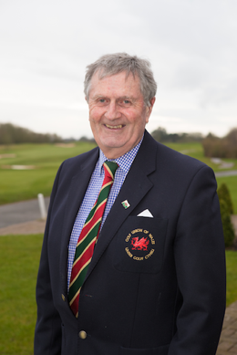
We congratulate all the winners at the Welsh Golf Awards earlier this year which demonstrates the good work being done at club level by everyone involved. This event has been sponsored by Future Financials and we thank them for their support over the last eight years. We are delighted to announce that these awards will now be supported by One Golf Network. It’s great to celebrate clubs and individual’s successes.

Richard Dixon continues to manage and support a dedicated team of staff whose hard work and commitment delivers the best possible programmes to support Welsh golf clubs and players. On behalf of the Board, Council and all Welsh clubs I would like to thank Richard and the staff, Jeff Harries our President, Andrew Emery our Treasurer, all our volunteers in the clubs and counties, the Youth Panel and Ambassadors, the Board, Council, all of whom make extremely valuable contributions to the success of Welsh golf.

Dr Val Franklin
Chairman

Treasurer’s Statement

Financial results for the 12 month period April 1st 2017 to March 31st 2018.

I am pleased to report on the second set of accounts I have been involved with as Treasurer of Wales Golf. This is actually the final set of accounts that reports on the structure which has Golf Development Wales reported as a separate company within the umbrella of the Golf Union of Wales. Going forward GDW has been absorbed within the new Wales Golf entity and will be treated as a cost centre within the organisation. It would be remiss not to comment on the enthusiasm and professionalism of all the staff at Wales Golf who continue to work tirelessly on behalf of the game in what continues to be a challenging environment.

The loss for the financial year 2017/18 is £11,060 which is well below the budgeted deficit set by the Board of £93k. Whilst income and expenditure within the Golf Development section of the organisation was closely aligned to budget, with a deficit of £37k there was an under spend within the Golf Union element, where a surplus of £25k was reported, a minor tax adjustment of £2k explaining the remainder of the movement. The primary reason for the lower deficit was a reduction in expenditure within the Teams and Performance elements of the business. This was partly due to some changes in the international events calendar which provided one off timing savings and 2017/18 was also a year without the Biannual World Amateur Team Championships. However the main factor was the transitional changes that the Director of T&P is making to the use of resources within this area, changes that have been fully communicated to the Board of Directors who are completely supportive of the strategic approach being adopted. I would not anticipate a similar under spend in the future as resources have been reallocated within T&P and in all other areas expenditure was in line with the budget set.

Once again, the total number of golfers attached to our member clubs has fallen. However, I am pleased to report that the overall reduction was less than 2% which is lower than the 3.2% reported in the previous year and a continuation of the trend pointing to the decline flattening out. Much more importantly the number of juniors affiliated to our members increased by 1%. Albeit, this is a small increase and only a single year figure, but after several years of decline in the number of juniors playing the game it is encouraging to see a positive indicator. Combined with the employment of a dedicated officer to promote the playing of the game by both women and juniors over the next few years, I am hopeful that clubs will continue to report a positive return in this area and indeed also report a growth in the number of females playing the game.

We continue to work closely with all of our main funding partners. As expected, with the challenging public spending environment continuing to prevail, our grant from Sport Wales has again been reduced but at the minimum level we would have expected. Importantly our team have continued to work very closely with them and this will be important going forward as pressure on funding is certain to continue. We also appreciate the tremendous support that the R&A provide to us. Their commitment to provide additional substantial support to help fund a Women’s Golf Officer over the next three years aligns with our belief that this is a crucial area of under representation that must be focussed on in the coming years as a clear area of potential growth. The Golf Foundation and the PGA continue to provide us with financial support and we also share knowledge and expertise with them in a mutually beneficial way.

My thanks to PING, Circle Insurance, One Golf Network and Pinnacle Office Solutions for their continued sponsorship and to Cloggau Gold for their support of the Welsh Ladies Team Championships in 2017. I hope we will continue to grow this kind of arrangement with commercial partners. Overall the Championship programme continued to not only run on a break even basis but also to consistently set the standard for how a national amateur event should be presented.

The balance sheet and reserves remain in a strong position and the Board strategy to operate a budgeted deficit to target resources on the growth of the game in Wales remains in place. In 2018/19 the budgeted deficit is £71k. The Board will also have in place a number of key performance indicators to monitor progress in our main areas of operation.

In conclusion, there is no doubt that substantial challenges continue to face the game in Wales and there is much hard work ahead. However, I do believe that the structural changes that have now been completed combined with the outstanding team working for Wales Golf provides the best opportunity to develop and grow golf in Wales.

Andrew Emery
Treasurer

Chief Executive’s Report

The following report details our work 2017/18

DEVELOPMENT

It has been a successful and exciting year for the development team as we begin to implement the new strategy ‘Everyone’s Game, Anywhere’ with a focus on women and girls development, inclusive golf and stronger clubs. Related to this a new Women and Girls Officer, part funded by the R&A was recruited in January. Further links to Health have been established and the Business Support Scheme, New2Golf, Junior Club Accreditation and Women and Girl events continue to be successful.

Key Successes Include:-

- 68,000 participants were introduced to golf.
- The new Active Lifestyles survey replaces the old Sport Wales Active Adults survey. Golf is shown as the 8th most popular activity overall (combining Walking/Rambling and Running/Athletics/Cross country) and the 5th most popular participation sport (Athletics, Swimming, Football, Cycling) Participation is at 5% of the population (9% males and 2% of females participate).
- Junior membership affiliation figures were up for first time in many years (1.1%) and 45% of clubs experienced an increase (or remained the same) in affiliation/ membership (43% in 2016). 3% increase in affiliation in Business Support Scheme clubs.
- 55% of New2Golf participants were female (50% in 2016) and 57% of all participants converted to trial membership.
- 123 clubs were supported by the Wales Golf Development team.
- 37 clubs have completed the strong club matrix health checker tool and are gaining Business Support with over 70 clubs registered on the system.
- 75% of clubs attended the most recent set of club support workshops.
- 33 clubs have achieved Junior GolfCert.
- £310,000 worth of lottery grants gained for Golf clubs over the past 3 years.
- Wales Golf continue to be a case study to other sports and were the only sport to be accepted in all three of the Sport Wales National Governing Body Early Adopter areas – Strategy and KPI’s, Collaboration and Governance. We are working towards the: Disability Sport Wales highest award - Insport Gold, the Advanced Equality Standards and have maintained the highest level in Safeguarding.

Golf, Health and Wellbeing

- Golf is in a great position to link to Health and Wellbeing. The security of existing funding from Sport Wales and the potential to attract new funding streams from health will be linked to how sport can contribute to this area.
- In 2017 a pilot of the New2Golf/Back2Golf Stroke Survivors scheme was set up at the Parc Golf Club in partnership with the Stroke Association. Nearly all the participants were lapsed golfers who did not have the confidence to go back to playing having survived a stroke. Nearly all are continuing to play and participate. It has been LIFE CHANGING for some. People who have socially isolated themselves and some with depression are participating regularly in a healthy activity outside and socialising.
- As a result of the success of this scheme, Golf is the first sport to attract funding direct from the Health Department within the Government to support a national roll out this year.

Business Support Scheme (BSS)

- There is now a more flexible approach to the BSS based around the needs of each club. Clubs and the development team utilise the Strong Club Matrix as a club health checker to assess the support needs of the club and also measure impact of our support over time. It is a tool which clubs and committees use in conjunction with their Golf Development Officer to help identify the strengths and areas for improvement of the club based around 9 key areas. These areas are: Governance, Participation, Marketing, Visitors, Membership Recruitment and Retention, Customer Service, Compliance, Course Rating and Course Management.
- Business Support is a combination of consultancy, cluster workshops on key themes, guidance from the regional Club Development Officer, as well as, access to a bank of templates and resources linked to the above areas.
- As part of the support clubs also have access to the Mystery Shopper Service and customer satisfaction survey tool called the Customer Feedback Tracker (CFT).
- The diagrams below (extracted from the Matrix) show that in October - 26 clubs had completed the matrix and in March - 37 clubs. The national averages have increased and over 70 clubs are registered on the system.

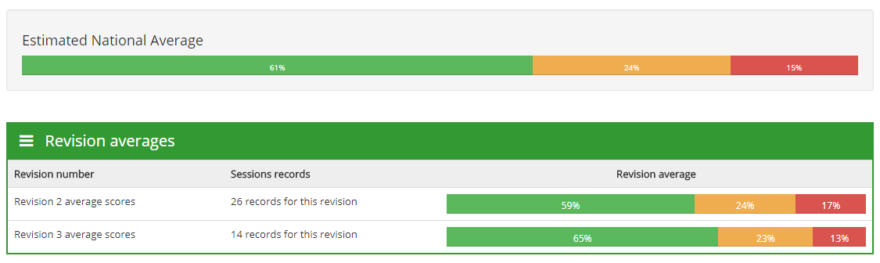
Matrix October 2017
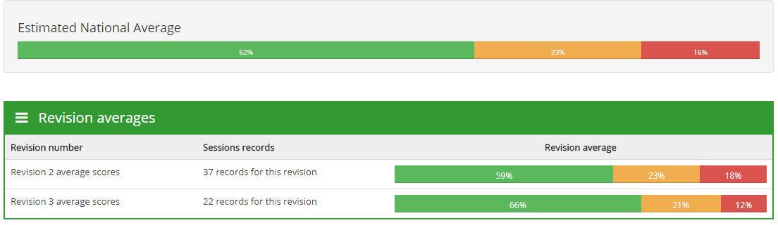
Matrix March 2018

Customer Feedback Tracker (CFT)

- The CFT (customer feedback tracker) is an online survey tool for clubs. Clubs use the system to develop a simple survey that can be sent to their customers. It collects the findings (which are measurable in each section) in an easy to read report, so golf clubs can use the information for planning and improving the customer journey over time. Aggregate data is also collected that Wales Golf uses to assist in strategy planning for club support.
- 22 clubs have completed or are completing a report either on the previous survey monkey or the new CFT.

Business Support Workshops

- Workshops between November and March took place around key themes emerging from the Matrix.
- The Compliance workshop which also looked at the new General Data Protection Regulations took place in November, delivered in partnership with the NGCAA.
Membership Recruitment and Retention took place in January delivered by Golf Marketing Consultant Jane Carter.
- In March 2018 the third and final club development workshop was on Customer Service delivered by consultant and former club manager Kevin Fish.
- 109 clubs out of 145 clubs (75%) attended the workshops. Total number of bookings was 398 and 278 people attended.

Club Governance Resource

- Wales Golf has produced a Club Governance resource in partnership with England Golf, Scotland Golf, GCMA, NGCAA and the PGA which has been available for a year.
- 1 free copy is available for clubs through the Development Officers. Clubs who have been on the Business Scheme workshops and who have applied for BSS will also be supplied with a copy.
- Phase 2 is currently being produced along with a bank of complimentary resources and templates

New2Golf/ Back2Golf

- This scheme provides clubs with funding to run a membership recruitment drive and aims to attract participants who are new to golf or those who have played in the past and are looking to join a club. Promotion can be targeted towards specific groups such as women and girls, families, disability groups etc. or general groups. It supports individuals through coaching, playing opportunities and social events prior to recruiting them to a variety of membership offers at the club.
- Marketing resources are produced each year supported by the R&A and focus on targeting the segments that are likely to be attracted to the sport. Marketing resources were produced for each campaign and targeted the following segments:
    - Females - All you need is Golf, Friendship and Laughter #sheplays2
    - Health – Keep Healthy, Keep Active and Stay Young #golf4health
    - Family - (campaign targeting parents/ guardians) – We Play, We Learn, We Grow - #thepowerofgolf #golffamilyfun

- Research shows (based on average New2Golf scheme figures), that running an effective New2Golf scheme can generate the club around £10,000 over 2 years.
- Focus groups have taken place with participants to learn from their New2Golf journey. A simple resource has been produced with hints and tips for clubs on how to run great New2Golf schemes. A copy can be downloaded http://www.walesgolf.org/beginner-coaching-grants/.
- In 2017 98 schemes took place at 52 clubs with 1541 participants and 878 trial members (57% conversion to trial membership). There was a slightly higher % conversion to trial membership than in previous years, with the same number of clubs applying. The % of females have gone up from 50% to 55%.

Girls Golf Development Hubs

- A focused initiative that aims to take the development of girls’ golf to another level. There were initially 6 pilot girls’ golf development hubs selected which has been expanded to 10.
- Our women and girls officer is currently visiting the sites with the development officer’s to look at ways to monitor, expand and improve the scheme.
Targets over 3 years
      - To recruit 30 – 60 girls to participate in regular coaching and social activities
- 50% to convert to club membership

Junior Club Accreditation

- This award has been developed to recognise those clubs attempting to increase the number of young people playing golf by providing a quality and fun experience. It also acts as a model for a junior section to strive towards. The application process is fully online and combines the Disability Sport Wales’ Insport accreditation. The Junior Golf Guide resource (an accompanying resource) is available to download from the Wales Golf website free of charge, or a club can order hard copies at a cost of £10.
- 33 clubs have achieved the new award online (of which 4 have achieved the higher award which is linked to Insport Ribbon).
- The new #Safegolf brand will be incorporated into this award. Clubs who have achieved accreditation will be able to use the new Safe Golf logo.

Youth Panel

- 15 young people with a wealth of experience, from Sport Wales young ambassadors to junior club golfers, have been recruited to form the Youth Panel. 50% of the youth panel members are female and 2 are golfers with a disability. The panel aims to give young people a voice and an opportunity to shape the future of Welsh golf. The Panel meets regularly and each member is given opportunities to take on project responsibilities. The 7th youth panel meeting took place in January. 4 youth panel members are involved in the National Leader Programme with the Youth Sport Trust supported by Sport Wales.

New2Golf Summer Swing

- This is a fun social gathering combined with a mini competition which includes a 36 flag and a nearest the pin competition. Amy Boulden or another professional takes the participant’s first tee shot for a nearest the pin competition. Local volunteers are used to walk with the groups and assist with scoring etc. Local companies sponsor the event, as well, Clogau Gold, Principality, LET, Mercedes Benz, the local bakery and bar.
- This event has been used as a case study by Sport Wales and featured in the R&A Woman and Girls and Family Golf research.
    - In 2015 - 58 participants – 50 females and 8 males
    - In 2016 - 60 participants – 36 females 24 males
    - In 2017 - 69 participants – 43 females 26 males

Girls Clinics

- The Golf Development girl’s clinics took place at North Wales Golf Club (North) and Pyle and Kenfig Golf Club (South) (August/Sept 2017).

Mini Masters

- Wales Golf supports the Mini Masters which is a 9 hole, beginner, fun competition for juniors with a 28 handicap or above, as well as, those new to the game.
- It is played on a short course with some modified rules, including a max of 10 shots per hole.
- These take place between May – Aug throughout Wales.
- https://www.walesminimasters.co.uk/

Coach and Volunteer Education

- Additional to the club support workshops, 4 level 1 ASQ Awards in Coaching Golf were organised with just under 40 people attending. As well as, 5 Safeguarding and Protecting children workshops with 61 people attending.

The Golf Foundation

- The Golf Foundation continue to support Wales Golf and invest £34,000 annually toward the development officer’s posts to help deliver the above, as well as Golf Foundation specific initiatives. The Street Golf Regional final took place at Cardiff City Stadium and was won by Bryn Meadows who progressed to the National Final at Formby Hall Golf Club, Liverpool. There were 27 HSBC Golf Roots funded centres with just under 8000 participants and we gained a donation from London Welsh Golf Society (LWGS) for 2 welsh projects through the Golf Foundation.

Development Grants
- The Development Officers have supported clubs and golf facilities through the application process to attract over £310,000 of grant funding for development projects through Sport Wales. In 2017 just under £100,000 was funded to Golf Clubs in Wales.

Initiatives to look out for in 2018/ 19
- All above schemes will continue to be rolled out.
- Club workshops running from October – March will cover themes of Compliance, Governance and Social Media.
- ASQ in Golf Coaching courses and Inclusive coaching courses have been scheduled, details to be found on www.walesgolf.org/workshops-roadshows/
- A bank of committee presentation tools have been, or are in the process of being produced, which include: Strategy and Business Planning, Marketing, Social Media, Running an Effective New2Golf scheme and Equality and Inclusion
- We will also see the introduction of new schemes such as a family pilot scheme, additional summer swing events and girls clinics, a women and girls week, a review on the girls hubs, women and girls forums and super sixes pilots.

For futher information on the above please contact our development team www.walesgolf.org/contact/

ELITE PERFORMANCE AND COACHING

The past 12 months have seen many performance and representative highlights across the various levels of Welsh Golf.
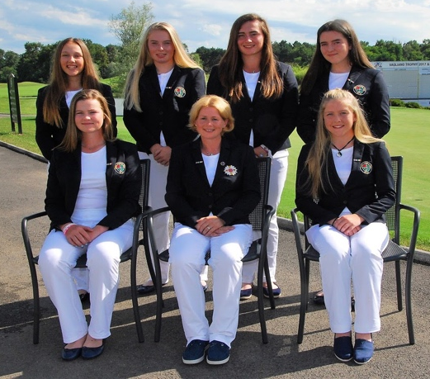
The main highlights included GB&I representative honours for David Boote and Jack Davidson in the Walker Cup team, which was captained by Andrew Ingram to compete against the USA in Los Angeles.

At boys level Luke Harries represented GB&I in the Jacques Leglise Trophy which was contested against the Continent of Europe in Ireland. Carys Worby and Ffion Tynan also earned GB&I honours when selected for the Vagliano Trophy played in Italy.

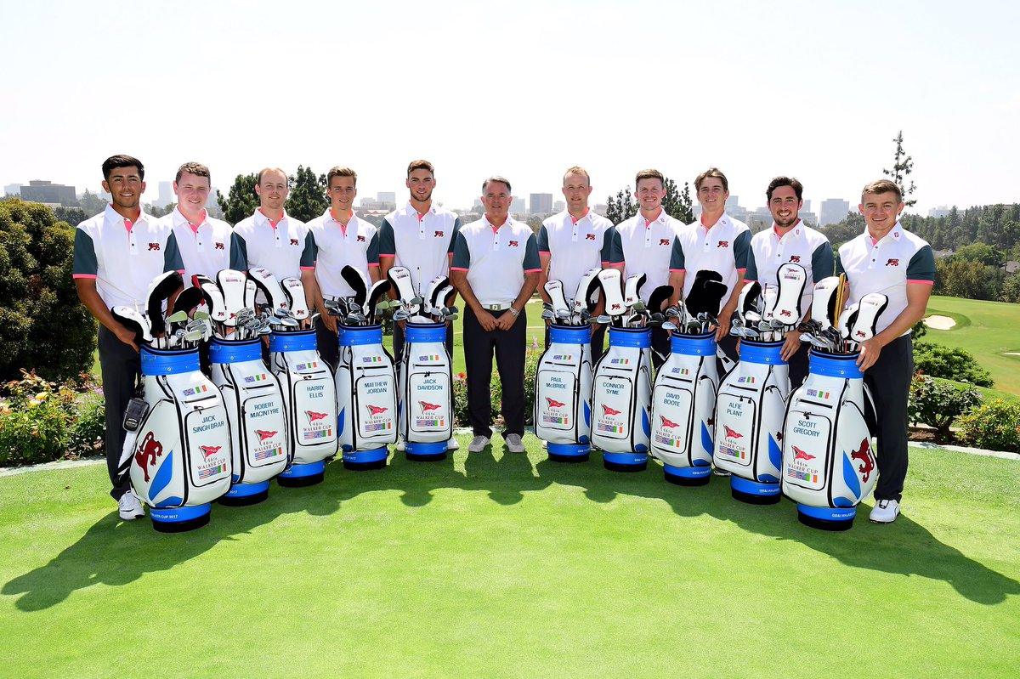
In team events, the highlight was the European Boys Team, which was led by Aled Greville and George Bryant who finished 3rd and 4th respectively in the qualifying stages, before Wales went on to finish in 3rd place and gain promotion to Division 1 for 2018.

However, there was disappointment for the Welsh Men’s team at European level as they finished 16th resulting in relegation to Division 2 for 2018.

There were 3rd place finishes for both the Men and Senior Ladies Home International Teams, with the Girls, Ladies and Senior Men all finishing 4th.

In terms of individual performances, the British Amateur Championship, played at Royal St Georges in June saw many strong performances from Welsh players. Evan Griffiths, Ben Chamberlain, David Boote, Llewellyn Matthews and Tim Harry all qualified for the match play stages which has been unprecedented in recent years. Evan and David went on to join the professional ranks at the end of the season, in addition to fellow European teammates Owen Edwards and Jack Davidson - Jack was subsequently named “Welsh Amateur Golfer of the Year” for 2017 due to numerous excellent performances at international events throughout the year.

At junior level there were many encouraging and strong performances, the most notable of which being at the Scottish Girls U16s Championship, where Ffion Tynan claimed 2nd place with Carys Worby, Ffion Vineall and Harriet Lockley all finishing inside the top 5 and ties.

Further highlights and notable performances on the international stage this year included:

- Lea Anne Bramwell 3rd Irish Girls Open Championship
- Owen Edwards Winner at West of England Championship
- Owen Edwards 7th at Lytham Trophy
- Luke Harries 7th at Fairhaven Trophy
- Kath O’Connor 4th at Irish Ladies Open
- David Boote 7th at English Amateur Championship
- Bethan Morris 5th at Welsh Ladies Open Championship
- Jordan Ryan 6th at Welsh Ladies Open Championship
- David Boote 4th at St. Andrews Links Trophy
- Jack Davidson 8th at St. Andrews Links Trophy
- Carys Worby 2nd at Henry Cooper
- Ffion Tynan 7th at Henry Cooper
- Josh Davies 5th at South of England Championship
- Jake Hapgood 8th at South of England Championship
- Jack Davidson 3rd at Welsh Open Stroke Play Championship
- Owen Edwards 4th at Welsh Open Stroke Play Championship
- Ffion Tynan 2nd at Scottish Girls U16s Open Championship
- Ffion Vineall T10th at English Girls Open Championship
- Aled Greville 3rd Round at British Boys Championship
- Bethan Morris 8th at English Women’s Open Championship

The 2017 Order of Merit winners were …

- Luke Harries (Tenby) Boys Order of Merit
- Ffion Evans (Newport Links) Girls’ Order of Merit
- Jack Davidson (Llanwern) Men’s Order of Merit
- Bethan Morris (Tenby) Ladies Order of Merit
- Nick Grimmit (Glamorganshire) Senior Men’s Order of Merit

CHAMPIONSHIP REVIEW

Congratulations to all our Champions, both individual and team. Lauren Hillier (Newport) claimed the Ladies’ spoils at Wrexham GC whilst Jack Davidson (Llanwern) topped a fantastic season with victory at Aberdovey GC. We wish him well as he takes to the professional ranks.

In the Team Championships, Pennard did the double! Having already claimed the Victory Shield, they overcame Celtic Manor in a thrilling final at Rhuddlan and Newport pipped Southerndown to once again retain the Ladies Team Championship at Vale of Llangollen.

In our Open Stroke Play Championships, England claimed the majority of the silverware. Gian-Marco Petrozzi (Trentham GC) led from start to finish at The Vale Resort for the Men’s Open Stroke Play and Gemma Clews (Delamere Forest) triumphed in the Ladies equivalent at a windy Ashburnham GC. Max Martin of Ladbrook Park enjoyed success in Wales as he claimed the Open Youths Championship at Prestatyn GC. Ian Crowther (Royal Lytham & St Annes) took the Men’s Open Seniors title but we did have a Welsh winner of the Ladies’ Open Seniors in Ann Lewis (Royal St David’s GC)

Once again the Championship Team ran a wide range of championships from junior through to seniors’ events some catering for elite amateur players and others for the enjoyment of club players across Wales. 2017 also saw the launch of the Senior Greensomes’ Championship. A summary of the winners of our national championships and Home International Team events is shown below:

TEAM CHAMPIONSHIPS | Winners | Runners Up
Welsh Ladies’ Team Championship | Newport Golf Club | Southerndown Golf Club
Welsh Team Championship | Pennard Golf Club | Celtic Manor Resort
Welsh Handicap Team Champ | Mond Valley Golf Club | Pennard Golf Club
Welsh Junior Inter Club Challenge | Llanwern Golf Club | Radyr Golf Club
Ping Welsh Mixed Team Challenge | Cottrell Park Golf Club | Creigiau Golf Club
Victory Shield | Pennard Golf Club | Conwy Golf Club
Boys’ Home Internationals | England | Ireland
Girls’ Home Internationals | England | Ireland
Men’s Home Internationals | Ireland | England
Ladies’ Home Internationals | Ireland | England
Senior Men’s Home Internationals | England | Ireland
Senior Ladies’ Home Internationals | England | Ireland

INDIVIDUAL CHAMPIONSHIPS | WINNER (CLUB) | RUNNER UP (CLUB)
Ladies’ Open Stroke Play | Gemma Clews (England) | Lianna Bailey (England)
Ladies’ Amateur | Lauren Hillier (Newport) | Alice Barnes (West Sussex)
Welsh Open Stroke Play | Gian-Marco Petrozzi (England) | Jack Gaunt (England)
Welsh Open Youths | Max Martin (England) | Thomas Williams (Wales)
Welsh Seniors | Paul Bloomfield (Kingsdown) | Brian Rigby (Glamorganshire)
Welsh Open Seniors | Ian Crowther (England) | Mark Stones (England)
Welsh Boys | Luke Harries (Tenby) | Harry Frazer (Pennard)
Welsh Girls | Caitlan Evans-Brand (Yelverton) | Darcey Harry (The Vale)
Welsh Amateur | Jack Davidson (Llanwern) | Tim Harry (The Vale)
Welsh Boys’ U16 | Bryn Thomas (Cilgwyn) | Tom Peet (Pyle & Kenfig)
Welsh Boys’ U14 | Jamie Dean (Carmarthen) | Connor Owen (Aberdovey)
Welsh Open Senior Ladies | Ann Lewis (Royal St. David’s) | Jane Rees (Minchinhampton)
GUW Medal | Helen Evans (Cottrell Park) | Nicola Wainwright (Rhuddlan)
Australian Spoons | Bryn Meadows  Dee Hughes & Eirlys Thomas | Langland Bay  Deb Howard & Chris Skubala
Challenge Bowls | Silver  Alison Williams (Mond Valley) | Bronze  Sian Smith (Dinas Powis)
Centenary Greensomes | Baron Hill  Debbie Roberts & Liz Madine | Coed-y-Mwstwr)  Julie Davies & Rebecca Roberts
Senior Greensomes | Tenby  Austin Davies & Jerry Whitehouse | Celtic Manor  Derek Bird & Les Slade

Rules Schools & Information
Our Championship Manager David Wilson joined the R&A Championship Committee at the 146th Open Championship at Royal Birkdale. David was one of a number of referees from all round the world officiating at the Open Championship.

The annual TARS course at St Andrews was postponed in early 2018 in preparation for the modification to the Rules of Golf in 2019. Ashton Bradbury & David Wilson attended a “teach the teachers” course hosted by the R&A course to help them in their preparations in running educational programmes in Wales in autumn 2018.

Welsh Junior Tour
The Welsh Junior Tour was initially launched with 4 events and a grand final in 2016, following its success a further event was added in 2017 and a three-year sponsorship deal secured with PING has been agreed. The age group winners are listed below:

Age Group | Winner | Runner-Up
Under 8’s | George Ledsham (Mold) | Harry Edwards (Builth Wells)
Under 10’s | William Pontin (Rhonnda) | Brodi Lewis (Pyle & Kenfig)
Under 12’s | Zak Baker (Llandrindod Wells) | Jack McKinney (Abergele)
Under 14’s Boys | Sean Hazelby (Carmarthen) | Iwan Fullick (Caerphilly)
Under 14’s Girls | Megan Vineall (Newport) | Darcey Harry (The Vale Resort)

HANDICAPPING & COURSE RATING

Handicapping and course rating (HCR) remain at the heart of the core services offered to affiliated golf clubs throughout Wales. Handicapping plays a hugely significant role in ensuring that golf can be played between golfers of all standards on an equitable playing field. An often complex system, we at Wales Golf, are continually looking to help educate those responsible for the administration of handicapping at club level whilst always seeking to improve our processes to be more engaging and user-friendly.

Over the past twelve months the handicapping and course rating department has completed the following:

- Handicap audit
- Category one handicap allocations
- Amateur status applications
- Preferred lies submissions
- Provided support and expertise on a number of club queries via club visits, meetings, telephone and email
- Management and implementation of changes to the CONGU Unified Handicapping System (UHS)
- Supported the development of World Handicap System (WHS)
Our dedicated HCR email address (handicapping@walesgolf.org) has proved to be an excellent tool since it was introduced a couple of years ago and has established itself as an effective method for clubs to receive quick effective advice on their handicapping and course rating queries.

The much publicised move to the WHS has been a particular focus of the team this year. A lot of background work has been done over 2017/2018 alongside the R&A, the USGA and other home unions to ensure that the eventual move to this system in 2020 is as smooth a transition as possible for our clubs. Workshops have been planned for the end of 2018 to act as an initial introduction for golf clubs and will provide an opportunity for the changes to be explained in much greater detail. We are excited about the introduction of this system and the positive impact it will have on amateur golfers.

The CDH remains a priority for Wales Golf and we will continue to develop the system to ensure it can deliver on its objectives whilst offering support and guidance to clubs, administrators and golfers alike. We are working with the other home unions with a view to the introduction of the WHS to develop a CDH system that is easier to understand and administer for both Wales Golf and our member clubs. Over 95% of clubs are now registered on the CDH.

Our Course Rating service has continued to tick over well this year. Clubs are regularly communicated with and better informed of the processes involved with course rating as well as understanding how and why we conduct Standard Scratch Score (SSS) reviews. The course rating team continues to receive training and we look forward to welcoming new raters to the team next year. Again we have seen an upsurge in 9 hole and short course SSS requests and we welcome golf clubs embracing a different way to play the game. We hope that the number of clubs requesting 9 hole and short course SSS will continue to grow in the future alongside initiatives from golf’s governing bodies to champion shorter formats of the game.

Wales Golf has retained the status of having three members on various CONGU Committees. This is important to us as a union as we look to shape the future of handicapping.

We would like to offer our sincere thanks to the committee members, course raters and other volunteers who have kindly given up their time to help us achieve our goals within HCR.

THE ONE GOLF NETWORK WELSH GOLF AWARDS

Welsh Golf Club of the Year
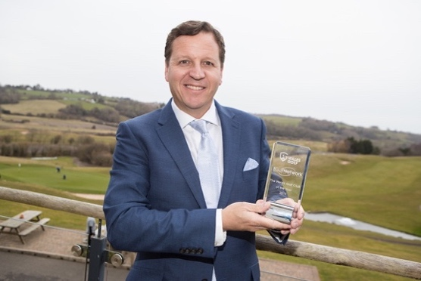
2017 saw the strongest ever set of applicants for the Welsh Golf Club of the Year with the following clubs being shortlisted: - Abersoch, Cardigan, Clyne, Newport (Rogerstone), North Wales and 2 former winners Langland Bay and Pyle & Kenfig.

This year’s winning club Bryn Meadows had submitted strong applications in the previous 2 years and 2017 saw many of their ongoing projects come to a successful fruition. They carried out extensive surveys with their customer base which led them to implementing the following over the last few years: -

- Appointing a Director of Golf and a female PGA professional
- Developing a junior membership pathway and academy which has seen junior membership numbers grow dramatically. In August 2014 they had barely a handful of junior members they now have over 100.
- Achieving Wales Golf Coaching Centre status and have 3 levels of junior membership.
- Operating a full junior competition and social calendar
- Becoming a Wales Golf Girl’s Hub with over 200 girls taking part in weekly sessions.
- Conducting regular coaching sessions in 20 local schools
- Introducing the US Kids programme
- Both the club’s junior teams won their respective junior leagues in 2017.
- Introducing a beginner lady membership, with each new lady member entitled to 6 group lessons, full use of the academy course and access to the full course from shortened tees. They currently have over 20 ladies in coaching and playing the academy course.
- Introduced a new family coaching and membership scheme.
- Making an assortment of tees available mean that Mum, Dad and kids can easily play together from different tees
- Having struggled to attract 20-30 year olds to join they offered a new intermediate membership and have attracted 40 new members in this age group.
- In 2017 began offering beginner lessons and keep fit classes for the over 50’s and are currently working with the Caerphilly over 50’s forum.
- Extending their facilities creating a new lounge area and introducing a state of the art golf simulator which is proving very popular particularly in the winter months.
- Investing significantly in green keeping machinery i.e. mowers, tractors and a drainage machine leading to big improvements in the year-round condition of the golf course.
- Making improvements to teeing areas, bunkers, pathways.
- Significantly investing in improvements to the course over a 2-year period.

Welsh Volunteer of the Year

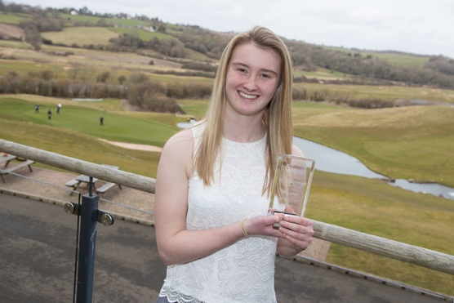
The 2017 Award for Welsh Golf Club Volunteer of the Year Award went to Shauna Lyons of North Wales Golf Club. Shauna has shown passion, commitment and drive in helping developing junior golf at her club, she has: -

- Attended and achieved her PGA Level 1 certificate in coaching golf to increase her knowledge
- Attended a Safeguarding & Protecting Children workshop
- Helps run 5 junion sessions a week with the juniors ranging from 4 to 17 years of age.
- Is the Junior Club Captain and is a great role model to all the juniors. She plays off a handicap of 5 and sets amazing standards with her outgoing and approachable personality. The junior girl members especially appreciate all her help and she keeps them involved in the game and very motivated.
- Volunteers to help at all the golf camps throughout the year.
- Is head of her school sports council and is also a gold level ambassador in her school meaning she consults with the PE department on key issues before they introduce them to other students.
- Delivers Tri Golf independently in school (under PE Supervision)
- Supports a PGA Pro at all high school golf sessions.

Welsh Amateur Golfer of the Year

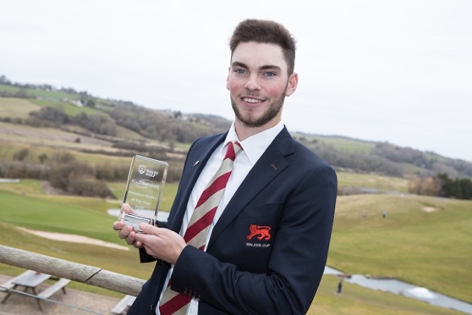
The 2017 winner was Jack Davidson who represented Wales in the Men’s Home Internationals for 2 years prior to 2017 but it was really in 2017 that his career took off. Here are some of his highlights:-

- 3rd Place place finish in South American Amateur in January.
- Winning the Spanish Amateur Championship in a very strong field.
- Individual winner of the European Nations Cup where he also helped Wales to a convincing win in the Team Event.
- Winning the Welsh Amateur Championship at Aberdovey .
- At Home Internationals at Moortown he won 4.5 out of 6 points including all 3 of his singles matches playing at number one in the order.
- Gaining selection for GB&I Walker Cup Team for Los Angeles Country Club alongside friend and fellow Welshman David Boote.

Welsh Tour Professional of the Year

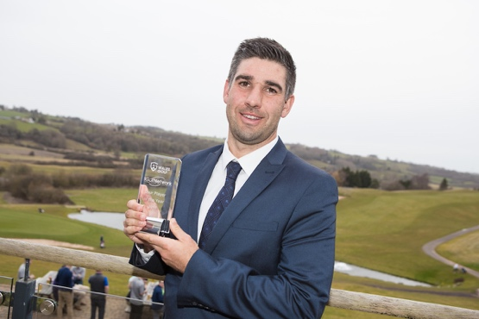
In 2017 Oliver Farr joined an illustrious group of winners of the Welsh Tour Professional of Year Award. Oly represented Wales at Amateur Level in the Home Internationals, European Team Championships and the Eisenhower Trophy before turning professional in 2011. Here are some of his achievements:-
- He first gained a full European Tour Card by finishing 10th on the Challenge Tour in 2015 helped by winning the Turkish Airlines Open.
- He lost his card for 2016 but bounced back by finishing 7th on the Challenge Tour in 2017 including a win in the Foshan Open and 5 other top 10 finishes earning over 130,000 euros.

Golf Development Wales, Professional of the Year

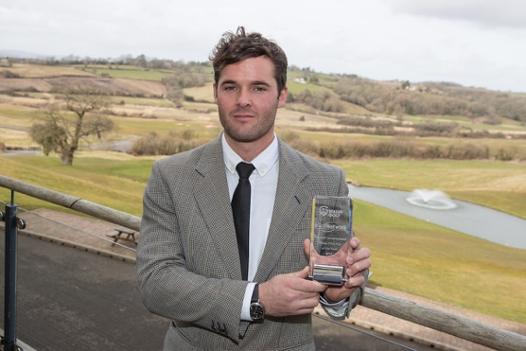
This award was presented to Robin Hughes of North Wales Golf Club, he is PGA professional who studied business management at Cardiff University where he captained the first team in the Premier League of the UK BUCs. In 2016 he went to the USA to coach in American academies and collages and he is currently in the final year of PGA training. Robin’s personal vision is to provide fun, inclusive golf opportunities for all, some of his achievements include:-

- Having 10,000 participants attending his golf sessions at his club and in the Community
- In the Spring & Summer he coaches on average 250 different people a week and in Autumn & Winter he averages 150 people a week.
- The Junior membership at his club has increased from 10 to 90 Junior members of which 25 are girls
- Over 400 primary school children have had 4-6 hours coaching.
- 150 children with learning difficulties experienced golf with 80 of these receiving 4-6 hours of coaching in the golf club environment.
- He has had 50 ladies in New2Golf sessions with 30 going on to join the golf club and he has had 30 men in New2Golf sessions with 12 of these joining the golf club
- In addition to his other community work he put on a school’s festival at the golf club during last Summer.
- He has helped establish a Junior team for the first time in 10 years and they now compete against other golf clubs in the local area.
- He rarely cancels any of his junior sessions, in poor weather he will conduct indoor golf activities such as putting and chipping or do fun quizzes on the rules and golf and etiquette.
- He is the Caernarfonshire County Boys Organiser
- His golf club is a Wales Golf Girls Hub.

Junior Club of the Year

This is the second time this award has been presented and this year’s recipient Mountain Ash Golf Club was a very worthy winner. In 2016 the club was down to just one junior member this energised the club committee to make a serious commitment to address the issue leading to the following dramatic results.: -

- In 18 months the junior membership increased to 60
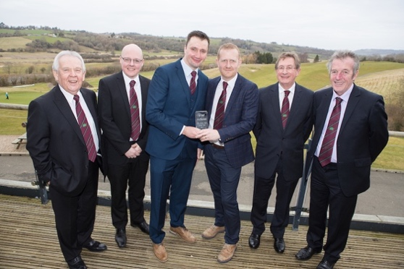
- Working closely with Golf Development Wales they organised golf festivals in local schools supported by a vigorous advertising campaign
- The Club attracted over 100 participants to its junior coaching schemes
- It now supports 3 very enthusiastic and capable junior organisers
- The philosophy is to make membership fully inclusive regardless of disability or social background
- There is a very strong emphasis on life skills, social skills and etiquette
- Their plans include taking juniors to experience other courses and during bad weather in the winter to hold indoor clinics and sessions on simulators in Cardiff.

Special Achievement Award

From time to time Wales Golf presents a Special Achievement Award to someone who has given outstanding service to Welsh Golf. In 2017 this award was presented to a very worthy recipient Nigel Edwards, his list of achievements is immense, here are just a few:-

Team Golf
- Represented Wales in Home Internationals from 1995 to 2010, 15 times in total.
- Represented Wales in 10 consecutive European Men’s Team Championship from 1997-to 2009
- Represented Wales in 4 Eisenhower Trophies (World Team Championships)
- Represented Europe 4 times in Sir Michael Bonallack Trophy v Asia Pacific.
- 2002 Home Internationals at Royal St David’s helped Wales win the Raymond Trophy for the first time.
- Played his first Walker Cup in 2001 when GB&I won at Sea Island, Georgia, GB&I Team included, Luke Donald, Graeme McDowell, Marc Warren, Michael Howey, Nick Dougherty and Gary Wolstenholme
- Played in 3 further Walker Cups including the win at Ganton in 2003, this was probably his most memorable, he played all four matches and remained unbeaten partnering fellow Welshman Stuart Manley in the foursomes.
- 3 times Captain of the GB&I Walker Cup Team, a record. GB&I won two at Royal Aberdeen, in 2011 and at Royal Lytham in 2015
- Represented GB&I 3 times in the St Andrews Trophy (GB&I v Continent of Europe) as a player and 3 times as non-playing captain.
Notable individual Achievements
- Won the Sherry Cup in 2006
- Won the South African Amateur in 2006 and was runner up in 2008.
- Played in South African Open in 2007 and made the cut.
- Reached number 3 in World Amateur Golf Rankings

Nigel worked for the Welsh Golfing Union/Golf Union of Wales for nearly 13 years from 1998 before taking the post of Director of Performance for England Golf in 2012.

Conclusion

Our Chairman highlighted in her report the recent re-branding process and the bringing together of Golf Development Wales and the Golf Union of Wales under the new Wales Golf banner. At the same time we launched a new 5 Year Strategic Plan which clearly identifies our priorities and objectives. Below you will find the one page version of the plan, please take the time to look at the full 12 page version which is downloadable form our website www.walesgolf.org. It is essential that we allocate our resources in the most effective way to take Welsh golf forward. We will remain focused on helping clubs to improve, encouraging greater numbers of participants and increasing club memberships particularly across female and family categories where the game has a massive opportunity to make significant progress.

We firmly believe that our best chance of achieving success across all areas of the game in Wales is to engage with and encourage the commitment and support of all golf’s stakeholders.

Richard Dixon
Chief Executive

