Wales Golf Equality Impact Assessment
Revisit Annually
Age, Disability, Gender Reassignment, Marriage & Civil Partnership, Pregnancy & Maternity, Race, Religion or Belief, Sex, Sexual Orientation
*Socio Economic Disadvantage
* Welsh Language
Green = Revisit annually
Red = Only revisit if changes to Policy

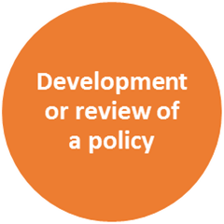 | Name of Project | Girls Golf Rocks/ Cymru
 | Is this a new policy being developed or a review of an existing project | New Project
 | Others involved in the assessment | Zoe Thacker
 | Dates(s) of EIA | 03 May 2019
 | What is the purpose and outcomes of the project? | A pilot programme aimed at interesting girls in golf and retaining them in the sport. The same as England Golf’s programme Girls Golf Rocks, it draws on research showing the importance of the social side of sport to many girls, and the benefits of girls-only coaching in lowering barriers such as lack of confidence and body image. Following a free taster session, girls can take up the opportunity of low-cost, girls-only coaching sessions with the emphasis on the fun, social and friendship aspects of golf. The programme aims to create an environment where girls feel comfortable and confident to participate and the centres offer a clear pathway for them to continue their enjoyment of the sport whilst growing their friendship circle.
 | Who are the customers for this programme? | Junior Girls aged, 6 – 18 from across Wales  It will also impact Golf Club officials, coaches, and volunteers
 | How has equality been considered in the development / review of the programme so far? | The project is a positive action programme to help reduce the gender imbalance that is present in golf.  We will aim to have all the programme inclusive, taking into consideration girls that belong to other equality groups such as BME, Disability (including Mental Health), areas of social deprivation, and Welsh language.  We will support key stakeholders within the project with the necessary skills to enable them to create and environment fully inclusive, by running Equality specific Workshops, seminars and courses.  We will make it compulsory for those running the programme to complete the Junior GolfCert accreditation prior to the becoming approved.  Pricing structure – England Golf were prepared to share their Girls Golf Rocks programme in terms of branding and content but were un-flexible on the price point. Even though this would save Wales Golf time and cost. We felt that this could disadvantage girls from deprived communities (especially when we had the funding to bring the pricing down). So we felt we should develop our own product which was the same as GGR and call it Girls Golf Cymru.  We have researched pricing structures of comparable sports in the area and have priced our Girls Golf Cymru offer to what we believe to be hugely valuable and competitive to sporting offers in these communities. Equipment will be provided and dress codes will be removed to lessen the financial barriers participants might have. We will consult with the communities as to what is the common languages used and make the necessary steps to provide all marketing material in the most effective language to achieve maximum engagement. All professionals running the Girls hubs will be given the opportunity to attend an Inclusive coaching Level 1 or Disability inclusion training, if not already achieved. Adapted equipment will be made available whenever possible to effectively deliver the project.
 | Who / what has driven this? | The gender imbalance with golf has encouraged the R&A to design and implement a strategy to address the issue, this is the driving force behind this project as well as the gender imbalance in Wales.
 | Why might it be important to consider equality and the protected characteristics? | It is fundamentally important to consider equality in golf. It’s a pillar of our organisational strategy.  Also in Wales as social deprivation is an additional protected characteristic it was vital to have a more flexible price point.  We recognise the equality issues within our game and assume full responsibility in helping to reduce the inequality that we find with our sport by taking positive action to steer our sport to a more inclusive environment and make golf Everyone’s game, Anywhere!

 | What does the data tell you about your customers and about protected equality groups? | After street games consultation and additional research – see link. £3.21 is the average household spend per week on sport/physical activity for most deprived households https://network.streetgames.org/sites/default/files/SIRC-street%20games-2016%20%283%29.pdf we therefore felt the England Golf pricing of £35 for 6 week per participant presented a barrier to girls from socio economically deprived communities.  The data shows that in Wales 13% of membership at Golf Clubs are female.  Wales has a BME population of 12% but our inner cities have a figure closer to 20%  The average price of junior female membership has reduced from £95 (2013/14) to £89 2015/16)  Poverty has a huge impact on levels of sports participation: 46% least deprived school age young people are ‘‘hooked on sport’’, compared to only 35% of young people living in the most deprived areas  “It’s all men and no women. If we could have someone we could look up to then you would become more interested.” Female non-golfer (14-15 age group)  In total, 29% of non-golfers and lapsed players we questioned said they would be very interested or interested in taking up golf in the next two years, equivalent to 36.9 million prospective new female customers.
 | What sources of data have you used? | Street Games research data  Welsh Golf Club Survey 2015/16s  School Sport Survey, 2013  Syngenta golf youth report  Syngenta Golf unlocking golfs true potential.
 | What do you need to know more about? | There are gaps in the data regarding BME junior participants and golf, we could collaborate with organisations such as BME Sport Cymru to carry out research in this area to identify the barriers and needs of BME communities.
 | How could you find this out and who could help you? | We have fantastic collaborative links with Disability Sport Wales, StreetGames, BMESportCymru and the Welsh equality sports alliance. We are constantly in direct communication with our partners to stay on the cutting edge of the equality agenda in Wales.

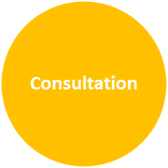 | Who have you consulted with from protected equality groups? | We have carried out women and girl forums. We have run focus groups within golf clubs. We have held clinics and events were we have discussed this project with participants and their parents. We have also consulted with the Wales Golf youth panel
 | Who else could you consult with? | We could consult with StreetGames, DSW, and  Youth Action Cymru, BME Sports and activity Forum.
 | Who can help you with this? | We could gain support from fellow colleagues from each of the organisations above.  WSA – Equality Sports Alliance

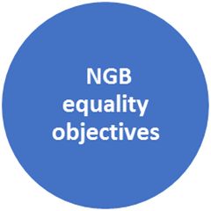 | How does the policy contribute to the NGBs strategic equality objectives? | The project contributes to the overarching vision of everyone’s Game, anywhere.  Support for pillar one “more golfers” we have a goal to increase girl’s participation by 20% by 2022. We strive to take positive action to make golf accessible to minority groups.
 | How could it be revised or changed to contribute more? | The strategy is a living document that will continue to evolve and progress as we increase our findings and adjust.

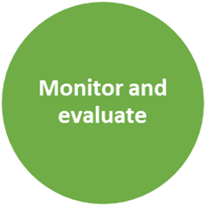 | How will you monitor and evaluate the Project? | Continue to run end of project Focus groups  To run an annual debrief with all key stakeholders to draw out learnings from the project to then leverage the learning to make a positive adjustment for the following year.  To monitor and evaluate the topics discussed at our own women and girls forums, as well as the forums of our key equality partners, BMESportCymru, DSW, Streetgames.  We will also analyse all Quantitative data captured to identify any trends that could help the adjustment of the project moving forward. We will also use the evaluation of the project to help us identify any barriers that potential groups might have encountered whilst trying to engage with the project.

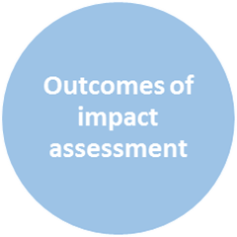 | Action | Timescale | Responsibility
 | To set our own pricing structure and run Girls Golf Cymru, and not align with the Girls Golf Rocks programme | Ongoing | Simon Lu
 | Attend all upcoming partner forums | Ongoing | Simon Lu
 | Consult langauage needs of Girls Golf Cymru clubs | As clubs register | Simon Lu
 | Check equipment needs with Girls Golf Cymru Clubs | As clubs register | Simon Lu
 | Check coaches training needs and support with courses if needed | As clubs register | Simon Lu

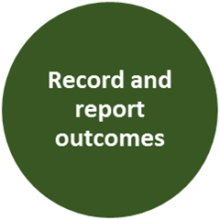 | Sign off
 | Signed by project Lead | Hannah Mcallister | Date | 20.05.2019
 | Signed by EIA Lead Officer | 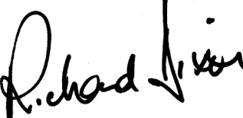  Richard Dixon | Date | 20.05.2019
 | Board Approval  (where applicable)  Chair | Val Franlkin  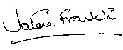 | Date | 20.05.2019

