Wales Golf Equality Impact Assessment
Revisit Annually
Age, Disability, Gender Reassignment, Marriage & Civil Partnership, Pregnancy & Maternity, Race, Religion or Belief, Sex, Sexual Orientation
*Socio Economic Disadvantage
* Welsh Language
Green = Revisit annually
Red = Only revisit if changes to Policy
Revisit Annually
Green = Revisit annually
Red = Only revisit if changes to Policy

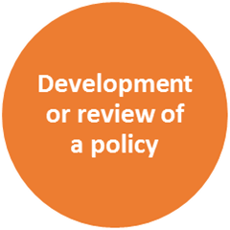 | Name of Project | Women in Golf Charter
 | Is this a new policy being developed or a review of an existing project | New Project
 | Others involved in the assessment | Zoe Thacker
 | Dates(s) of EIA | 15 September 2019
 | What is the purpose and outcomes of the Project? | - Strengthen the focus on gender balance  - Commit organisations to support measures targeted at increasing participation of females in golf  - Call on signatories to take positive action to support the recruitment, retention and progression of women working at all levels of the sport  - Develop an inclusive environment for women and girls within golf
 | Who are the customers for this programme? | The Women in Golf charter is essential for all involved in golf, from participation, workforce and elite. It will strengthen golf not only for women and girls but the sector as a whole
 | How has equality been considered in the development / review of the programme so far? | Equality has been considered in the implementation of the Women in Golf charter by asking signatories how they have considered participants that share other protected characteristics such as BAME, Disability and participants from Low socio economic communities and how the planed actions in their Women in Golf charter would impact their access to participating and working in golf.
 | Who / what has driven this? | The R&A unveiled a new Women in Golf Charter on 29 May 2018 in London as part of the organisation’s global drive to increase the number of women and girls participating in golf and to encourage more opportunities for women to work within the golf industry.  The data shows that in Wales only 13% of members at Golf Clubs are female.
 | Why might it be important to consider equality and the protected characteristics? | It is fundamentally important to consider equality in golf as it’s embedded throughout Wales Golf’s organisational strategy. We recognise the equality issues within our game and assume full responsibility in helping to reduce any disadvantages that we find with our sport by taking positive action to steer our sport to a more inclusive environment and make golf Everyone’s game, anywhere. The Charter is specifically designed to tackle the gender imbalance but will also support the integration of more diversity in the sport overall

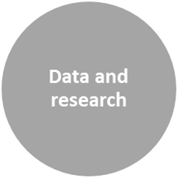 | What does the data tell you about your customers and about protected equality groups? | The data shows that in Wales 13% of membership at Golf Clubs are female.  The Average price of junior female membership has reduced from £95 (2013/14) to £89 2015/16  Poverty has a huge impact on levels of sports participation: 46% least deprived school age young people are ‘‘hooked on sport’’, compared to only 35% of young people living in the most deprived areas  “It’s all men and no women. If we could have someone, we could look up to then you would become more interested.” Female non-golfer (14-15 age group)  In total, 29% of non-golfers and lapsed players we questioned said they would be very interested or interested in taking up golf in the next two years, equivalent to 36.9 million prospective new female customers.
 | What sources of data have you used? | - Welsh Golf Club Survey 2015/16  - School Sport Survey, 2013  - Syngenta golf youth report  - Syngenta Golf unlocking golfs true potential.
 | What do you need to know more about? | There are significant gaps in the data regarding BAME participants and golf, we could collaborate with organisation such as BMESportCymru to carry out research in this area to identify the barriers and needs of BME communities. We need to better understand what motivates women to take up golf, and identify the solutions to any barriers they encounter.
 | How could you find this out and who could help you? | We have fantastic collaborative links with Disability Sport Wales, StreetGames, BMESportCymru, Women in Sport, The R&A and the Welsh equality sports alliance. We are constantly in direct communication with our partners to stay on the cutting edge of the equality agenda in Wales.

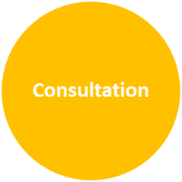 | Who have you consulted with from protected equality groups? | We have carried out Women and Girl Forums, we have run Focus groups within golf clubs, we have held clinics and events were we have discussed this project with participants and their parents. We have consulted with the Wales Golf youth panel. We are regularly attendees at the BAME Forum in Newport and consult their expertise regarding all projects.
 | Who else could you consult with? | We could consult with StreetGames, DSW, Women in sport, and  Youth Action Cymru, BME Sports and activity Forum. LGBT sport network.
 | Who can help you with this? | We could gain support from fellow colleagues from each of the organisations above.

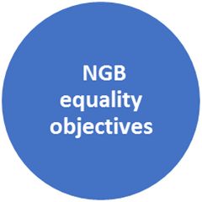 | How does the project contribute to the NGBs strategic equality objectives? | The project contributes to the overarching vision of everyone’s Game, anywhere.  Support for pillar one “more golfers” we have a goal to increase girl’s participation by 20% by 2022. We strive to take positive action to make golf accessible to minority groups.
 | How could it be revised or changed to contribute more? | The strategy is a living document that will continue to evolve and progress as we increase our findings and adjust.

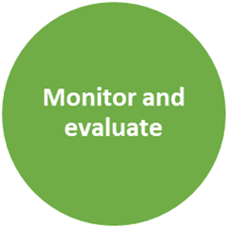 | How will you monitor and evaluate the Project? | Continue to run end of project Focus groups  To debrief with all key stakeholders to draw out learnings from the Curtis cup aspect of the project to then leverage the learning to make a positive adjustment for the following year and the Women’s British open aspect of the project.  To monitor and evaluate the topics discussed at our own women and girls forums, as well as the forums of our key equality partners, BMESportCymru, DSW, Streetgames.  We will also analyse all Quantitative data captured to identify any trends that could help the adjustment of the project moving forward. We will also use the evaluation of the project to help us identify any barriers that potential groups might have encountered whilst trying to engage with the Women’s British Open project.

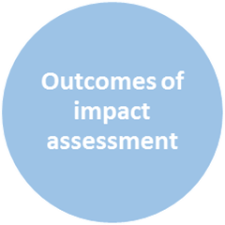 | Action | Timescale | Responsibility
 | Attend all upcoming partner forums | Ongoing | Simon Lu
 | Consult langauage needs of Legacy project Criteria | As clubs register | Simon Lu
 | Check equipment needs with Legacy project delivery Clubs | As clubs register | Simon Lu
 | Check coaches training needs and support with courses if needed | As clubs register | Simon Lu

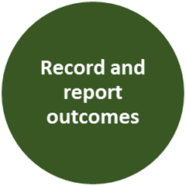 | Sign off
 | Signed by project Lead | Simon Lu | Date | 20.04.2019
 | Signed by EIA Lead Officer | Richard Dixon | Date | 20.04.2019

