To: All Affiliated Golf Clubs 17th November 2020

Dear Secretary

Golf Union of Wales Ltd AGM, Thursday 17th December 2020

via zoom Video Conferencing

at

18.30 hrs

Please find enclosed the following papers: -

1 Formal Notice of the AGM

2 A proxy form including notes to the proxy form and notes re voting and weighting of votes.

3 An Agenda for the 2020 AGM

4 A copy of the draft regulations referred to in Special Business (see Notice of AGM).
At the following link on the Wales Golf website https://www.walesgolf.org/memorandum-articles-association-2/ a copy of the draft regulations showing the tracked changes to the Articles of Association can be downloaded as can all other documents enclosed with this communication.

5 Minutes of the 2019 AGM

Meeting login/registration details, a copy of the annual accounts for the financial year ended 31st March 2020 together with the Directors' Report will be circulated in due course.

If you have any queries regarding the enclosed please do not hesitate to contact me.

Yours sincerely

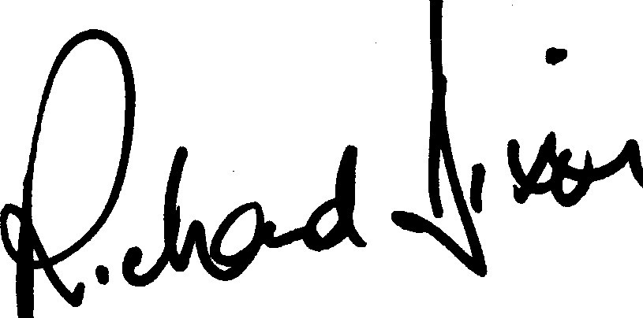

Richard Dixon
Chief Executive

