To: All Affiliated Golf Clubs 20 September 2018

Dear Manager/Secretary

RE: GRANTS FOR GREENKEEPER TRAINING

Please find enclosed a Greenkeeper Training Grant Application Form. As in previous years, applications will only be considered from affiliated golf clubs sending Greenkeepers to GTC approved colleges (Bridgend College, Pencoed and Coleg Cambria, Northop) in Wales. Grants will not be awarded, however, in respect of greens staffs that qualify for Apprenticeship status.

For further information on the course available please click below:
- Bridgend College
- Coleg Cambria

All greenkeeper training grant applications will be considered on their individual merit and any grants issued will be based on a percentage of accrued tuition fees, no grants will be given in respect of accommodation.

All grant applications together with all relevant invoices should be forwarded to the Golf Union of Wales by no later than 1st November 2018. Applications received without invoices will not be processed. Grants will be processed week beginning 1st December 2018.

If you have any queries regarding the grant application process please do not hesitate to contact me.

Yours sincerely

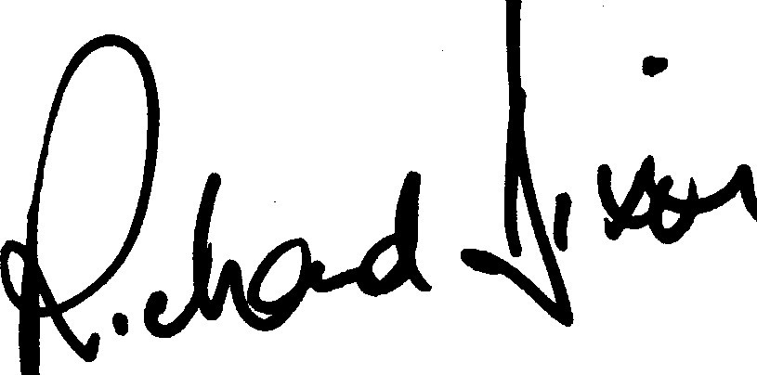

Richard Dixon
Chief Executive

