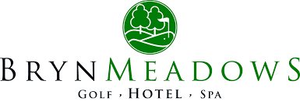
Women in Golf Charter Pledge 2018

Bryn Meadows Golf, Hotel & Spa vision is to make Golf as accessible and encouraging for Women as possible. By signing this pledge, we hope that this will further demonstrate our commitment to Women’s Golf.
We are proud not only to have signed the Charter but to have already achieved the following:
- Employment of 2 Female PGA Professionals
- Successfully introduced 8 Ladies onto a New2Golf membership scheme supported by Wales Golf in 2018.
- 17 Girls part of our Junior Membership.
- 37 Fully Affiliated Lady Members.
- We utilize our facilities by offering Spa & Golf Packages.
- 28 Ladies signed up for regular weekly coaching sessions since September 2018.
- We have 2 women and 6 men that formulate our club committee.

We will commit to:
- Continue our support for Women in Golf by developing and advertising our coaching programs available.
- Offer Women Only coaching sessions on a weekly basis.
- Creating a comfortable and welcoming atmosphere in our club house by not instilling a strict dress code.
- Utilize our facilities to create another avenue to encourage Women’s Golf.
- Making our goal to increase our lady membership by 10% in 2019.
- Increasing our female participation in coaching by 20% (From 28 up to 34) in 2019. We already have a coaching log tracking each session on a weekly basis. We aim to target our lady gym members as well as the locality via social media and newsletters.
- We hope to increase our Girls membership from 17 to 25 in 2019. We hope to do this by becoming a Girls Golf Hub and to offer Girls Only coaching sessions.

Signed Gary Mayo

