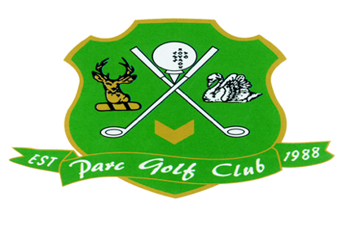
PARC GOLF CLUB
CHURCH LANE
CODEKERNEW
NEWPORT
GWENT
NP10 8TU
Telephone (01633) 680933

Women in Golf Charter Pledge

A commitment to establishing an Inclusive Culture across all areas of the golf clubs’ services for its members, guests and staff.

Parc Golf Club present this charter as a commitment of the club’s intent to be one of the pioneers of the development of the game. The club is proud to support the R&A on the launch of the Women in Golf and are proud to become a signatory.

As a club we are working towards:
- Achieving 40% female representation on our committee
- Implementing recruitment initiatives targeting women/girls/families
- Addressing strategies to support female retention
- Implementing a membership pathway for women and girls to progress within our club structure
- Supporting national New2Golf women and girls’ campaigns addressing perception, recruitment and retention
- Providing volunteering opportunities for women and girls within our club
- Adopting an inclusive approach with female and family imagery displayed throughout the clubhouse and website
- Introducing regular social activities for women and girls at the golf club
- Work alongside the Local Authority to create awareness of the game in the local community
- Continue to provide Inclusive Coaching and highlight that the club has achieved the Disability Sport Wales Ribbon Award

We are committed to achieving our pledge and look forward to working collaboratively with Wales Golf and the R&A to ensure that we can achieve this.

Carl Hicks
Proprietor

