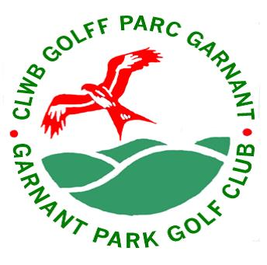

GARNANT PARK GOLF CLUB

WOMEN IN GOLF CHARTER

30 NOVEMBER 2020

Garnant Golf Club has a long tradition of encouraging and embracing women and girls into the game of golf and wholeheartedly pledges its support and commitment to the Women in Golf Charter. Our mission is to make golf accessible to all and we provide inclusive opportunities both on and off the course and across all areas of our operation. We are open to everyone and have one of the strongest representations of women and junior girl golfers in Wales.

This Charter is a set of objectives that supports our commitment to develop women’s, girls’ and family golf at Garnant Park Golf Club. There are 7 core commitments, which are outlined below.

GARNANT GOLF CLUB CHARTER COMMITMENTS

- Aim to increase our Women Section in 2021 from the ladies we have recruited through the New2Golf initiative that we started in August this year.

- Start a New2Golf initiative for women and girls in 2021 to increase women and girl members in 2022.

- Continue our Women’s Academy consisting of women from New2Golf who have joined our Winter Membership and support them to develop their golf further. The aim is that we keep them engaged and prepared to so that they take out full membership in April 2021.

- Keep developing a range of social activities, golf activities, competitions, matches and friendly golf that encompasses all age groups and membership types.

- Continue to support and encourage women’s involvement in taking on roles in the Club matching skills to vacant posts. Currently 31.5% involvement.

- Create and run a calendar of annual events for family golf.

- Communicate, promote and publicise the Charter within and beyond Garnant Golf Club. These commitments form part of a three year rolling plan to develop women’s, girls’ and family golf at Garnant Golf The plan will be reviewed by the Executive Committee at Garnant Golf Club and Wales Golf on an annual basis.

The attached table summarises our current situation and actions we have set out to achieve the Charter commitments in year 1 beginning on 30 November 2020.

Sandra Davies, Charter Champion

Signed S Davies Date 30 November 2020

