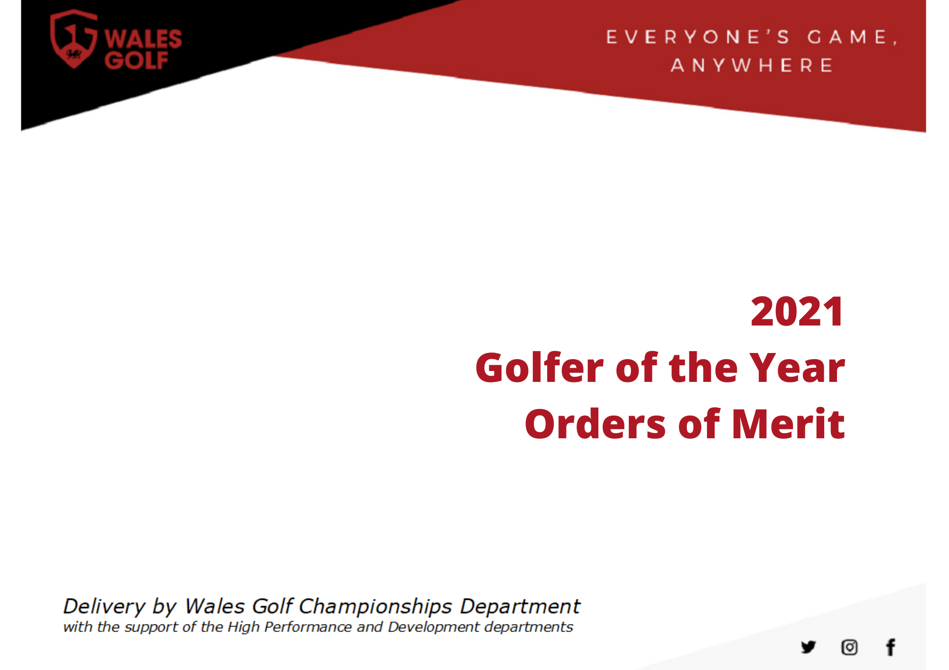

**Contents**

Introduction

* Golfer of the Year
* Order of Merit

Girls’ Schedule, Points Categories & Notes

Women’s Schedule, Points Categories & Notes

Boy’s Schedule, Points Categories & Notes

Men’s Schedule, Points Categories & Notes

Senior Men’s Schedule, Points Categories & Notes

**Introduction**

Golfer of the Year

The purpose of the Wales Golf “Golfer of the Year” (GoY) is to promote amateur golf competitions in Wales, by providing a recognised domestic competition program of events for national amateur golfers, and to recognise these achievements. In addition to this, it is envisaged that the GoY will enable Wales Golf to build relationships with counties and clubs through advice and resources for running of events (via WG championships team).

Orders of Merit

The purpose of the Wales Golf “Orders of Merit” (OOM) is to provide a recognised schedule of events in which Welsh amateur golfers can compete within their respective categories. A consistent system of awarding points will be applied across domestic and international competitions, ensuring the amateur golfers that perform are suitably rewarded within their respective table. The tables of players produced are not intended to form a strict ranking of Wales amateurs by ability and outside of automatic selection places (details of which can be found in the relevant Wales Golf Selection Policies, which are available online) the Orders of Merit will not be utilised as to aid selection of Welsh national teams.

**Main Notes**

Points tables will be **updated on a weekly basis**

* Updated tables will be published online each Wednesday
* Only completed events will be updated
* **Queries should be emailed to** [**championships@walesgolf.org**](mailto:championships@walesgolf.org)

Points allocated are subject to the following conditions, at the discretion of the GoY/OOM selection committee

* Average points will be awarded for “tied” finishing positions
* Additional points may be awarded for performances of outstanding achievement in International Championships (OOM only) not listed
* Country Championships can request to be included in GoY (if 54 holes or more)
* Points awarded may be reduced if the number of holes completed in an event are reduced for any reason
* Points will not be awarded for Championships/events where there is a restriction to entry other than ballot of handicap (or WAGR ranking)

As outlined in the relevant Wales Golf Selection Policies, automatic selections for Welsh Teams will be based on the relevant OOM but further to this, the **GoYs & OOMs will not be considered to aid selection** of theremaining team members to represent Wales.

**Girls’ Golfer of the Year** *(sponsored by PING)*

Schedule

17 - 18 Apr Mid Wales Girls Borth/Aberdovey E

22 – 24 May Welsh Ladies Closed Wenvoe Castle B

18 – 19 Jul Welsh Girls (Qualifying) Cardiff D

20 – 21 Jul Welsh Girls (Match Play) Cardiff B

24 – 26 Sept Welsh Ladies Open Strokeplay Newport A

Points Categories



Notes

* The purpose of the Wales Golf Girls Golfer of the Year (Girls GoY) is to encourage developing players to compete in Welsh events by acknowledging and rewarding the player who performs most consistently across the year.
* Please note that the Girls GoY is not considered when selecting international teams … please see the Wales Golf Girls Selection Policy (available online) for information relating to the selection of Welsh teams for major international events, including the selection process, criteria and factors considered by the selection committee.

**Ladies Golfer of the Year & Order of Merit** *(sponsored by PING)*

Schedule

16 – 18 Apr Scottish Ladies’ Open Strokeplay* Royal Troon & Troon Portland (SCO) C  
07 – 09 May Irish Ladies’ Open Strokeplay* Co. Louth (IRL) C  
22 – 24 May Welsh Ladies’ Close Wenvoe Castle E  
29 – 30 May St Rule Trophy* St Andrews Links (SCO) C  
07 – 12 Jun Ladies’ British Open Amateur* Kilmarnock (SCO) A  
21 – 24 Jul European Ladies Individual* Alwoodley (ENG) B  
17 – 19 Aug English Women’s Open Strokeplay* Wallasey (ENG) C 24 – 26 Sept Welsh Ladies’ Open Strokeplay Newport C

*\*Order of Merit event only*

Points Categories



Notes

* Players making the cut in the Scottish, Welsh, Irish or English Ladies Open Strokeplay or British Ladies Open Amateur or European Ladies’ Individual will be awarded 50 points for making the cut plus additional points for their finishing position as per the current table. e.g. A player who wins the Scottish Ladies Open Strokeplay will be awarded a total of 300 points (50 for making the cut and 250 for winning the Championship)
* Players who qualify for the Ladies’ British Open (RICOH) will be awarded 150 points and an additional 100 points for making the cut.
* Please note that the Ladies GoY & OOM is not considered when selecting international teams … please see the Wales Golf Ladies Selection Policy (available online) for information relating to the selection of Welsh teams for major international events, including the selection process, criteria and factors considered by the selection committee

**Boys’ Golfer of the Year & Order of Merit** *(sponsored by PING)*

Schedule

Postponed until 2022 Central Wales Boys Open Borth and Ynyslas H

07 - 09 Apr Scottish Boys Championship* Lundin (SCO) D

17 - 18 Apr Trubshaw Cup Ashburnnham/Tenby E

30 Apr – 02 May Fairhaven Trophy* Fairhaven (ENG) B

09 – 09 May Clwyd Open Prestatyn/Wrexham E

Postponed until 2022 North Wales Boys’ Open Rhuddlan / Abergele F

13 – 16 May Welsh Open Stroke Play Championship Machynys A

28 – 30 May Welsh Open Youths Whitchurch D

03 – 04 Jun Tucker Trophy Newport / Whitchurch E

18 – 20 Jun Henry Cooper Junior Masters* Nizels (ENG) B

26 – 27 Jun St Davids Gold Cross Royal St David’s D

29 Jun – 02 Jul Irish Boys Championship* Athenry (IRL) D

05 – 06 Jul Aberconwy Trophy Maesdu / Conwy E

14 – 16 Jul South Wales Boys’ Open (Strokeplay) Builth Wells F

14 – 16 Jul South Wales Boys’ (Matchplay) Builth Wells G

18 – 19 Jul Welsh Boys’ (Strokeplay) Cardiff E

20 – 21 Jul Welsh Boys’ (Matchplay) Cardiff C

24 – 28 Jul Welsh Amateur Championship Pyle and Kenfig A

10 – 15 Aug British Boys’ Championship* Royal Cinque Ports, Deal A

and Princes (ENG)

25 – 26 Aug Peter McEvoy Trophy* Copt. Heath (ENG) B

24 – 26 Sept Duncan Putter Southerndown D

*\*Order of Merit event only*



Points Categories

|  |  |  |  |  |  |  |  |  |  |  |  |  |  |  |  |  |  |  |  |  |  |  |  |  |  |  |  |  |  |  |  |  |
| --- | --- | --- | --- | --- | --- | --- | --- | --- | --- | --- | --- | --- | --- | --- | --- | --- | --- | --- | --- | --- | --- | --- | --- | --- | --- | --- | --- | --- | --- | --- | --- | --- |
| Group | 1 | 2 | 3 | 4 | 5 | 6 | 7 | 8 | 9 | 10 | 11 | 12 | 13 | 14 | 15 | 16 | 17 | 18 | 19 | 20 | 21 | 22 | 23 | 24 | 25 | 26 | 27 | 28 | 29 | 30 | 31 | 32 |
| A | 400 | 240 | 160 | 160 | 120 | 120 | 120 | 120 | 60 | 60 | 60 | 60 | 60 | 60 | 60 | 60 | 40 | 40 | 40 | 40 | 40 | 40 | 40 | 40 | 40 | 40 | 40 | 40 | 40 | 40 | 40 | 40 |
| B | 300 | 180 | 120 | 90 | 75 | 66 | 57 | 51 | 45 | 42 | 39 | 36 | 33 | 30 | 27 | 24 | 21 | 18 | 15 | 12 | 11 | 10 | 9 | 8 | 7 | 6 | 5 | 5 | 4 | 4 | 4 | 4 |
| C | 250 | 150 | 100 | 100 | 63 | 63 | 63 | 63 |  |  |  |  |  |  |  |  |  |  |  |  |  |  |  |  |  |  |  |  |  |  |  |  |
| D | 200 | 120 | 80 | 60 | 50 | 44 | 38 | 34 | 30 | 28 | 26 | 24 | 22 | 20 | 18 | 16 | 15 | 14 | 13 | 12 |  |  |  |  |  |  |  |  |  |  |  |  |
| E | 150 | 90 | 60 | 45 | 38 | 33 | 29 | 26 | 23 | 21 | 19 | 18 |  |  |  |  |  |  |  |  |  |  |  |  |  |  |  |  |  |  |  |  |
| F | 100 | 60 | 40 | 30 | 25 | 22 | 19 | 17 |  |  |  |  |  |  |  |  |  |  |  |  |  |  |  |  |  |  |  |  |  |  |  |  |
| G | 100 | 60 | 40 | 40 |  |  |  |  |  |  |  |  |  |  |  |  |  |  |  |  |  |  |  |  |  |  |  |  |  |  |  |  |
| H | 75 | 50 | 30 | 25 | 20 | 15 | 12 | 10 | 7 | 5 |  |  |  |  |  |  |  |  |  |  |  |  |  |  |  |  |  |  |  |  |  |  |
|  |  |  |  |  |  |  |  |  |  |  |  |  |  |  |  |  |  |  |  |  |  |  |  |  |  |  |  |  |  |  |  |  |

Notes

* Welsh Open Stroke Play - Boys who make the cut in this event will be awarded points equivalent to their finishing positions as Junior (F) rated tournaments when such points are greater than their entitlement from the Welsh Open Stroke Play (B) tables.
* The Welsh Boys’ Stroke Play Championship will be played during the qualifying rounds of the Welsh Boys’ Championship.
* The Scottish Boys, The Irish Boys, Welsh Open Youths, Duncan Putter, and British Boys – Players making the cut in these events will be awarded 50 points plus the points gained from their finishing positions. E.g. A player reaching the quarter finals of the British Boys will be awarded 150 points (50 points for making the cut plus 100 for reaching the quarter finals).
* Players making the cut in The Henry Cooper, McEvoy Trophy and Fairhaven Trophy events to receive 75 points.
* Please note that the Boys GoY & OOM is not considered when selecting international teams … please see the Wales Golf Boys Selection Policy (available online) for information relating to the selection of Welsh teams for major international events, including the selection process, criteria and factors considered by the selection committee

**Men’s Golfer of the Year & Order of Merit** *(sponsored by Pinnacle – Complete Office Solutions)*

17 – 18 Apr Trubshaw Cup Ashburnnham/ Tenby F

30 Apr – 02 May Lytham Trophy* Royal Lytham and St Annes (ENG) B

09 – 09 May Clwyd Open Prestatyn/ Wrexham F

13 – 16 May Welsh Open Strokeplay Machynys C

20 – 23 May English Open Strokeplay (Brabazon)* Ganton (ENG) B

28 – 30 May Scottish Open Strokeplay* Southerness (SCO) C

03 – 04 Jun Tucker Trophy Newport / Whitchurch F

04 – 06 Jun St Andrews Links Trophy* St Andrews Links (SCO) B

14 – 19 Jun British Amateur* Nairn and Nairn Dunbar (SCO) A

26 – 27 Jun St Davids Gold Cross Royal St Davids F

19 – 20 Jun The Berkshire Trophy* The Berkshire (ENG) C

23 – 26 Jun European Individual* Golf Du Medoc (FRA) B

05 – 06 Jul Aberconwy Trophy Maesdu / Conwy F

TBC The Walton Heath Trophy* Walton Heath (ENG) C

24 – 25 Jul Welsh Amateur (Strokeplay) Pyle and Kenfig F

26 - 28 Jul Welsh Amateur (Matchplay) Pyle and Kenfig D

12 – 15 Aug Irish Open Strokeplay* Galway (IRL) C

24 – 26 Sept Duncan Putter Southerndown E

*\*Order of Merit event only*

Points Categories

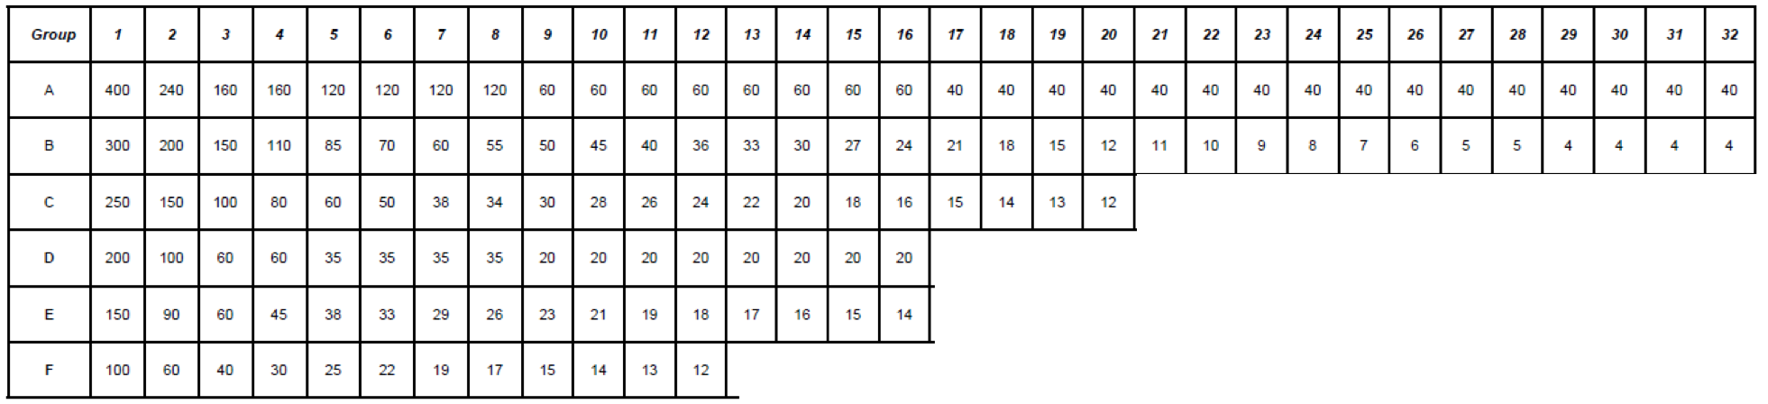

Notes

* Players making the cut in the Lytham Trophy, St Andrews Links Trophy, European Individual and the British Amateur will be given 75 points for making the cut plus additional points for their finishing position as per the current table. e.g. A player who wins the British Amateur will be awarded a total of 475 points (75 for making the cut and 400 for winning the Championship).
* Players making the cut at the English Open Stroke Play (Brabazon) will be awarded 25 points, any player in the top 36 & ties will get an additional 50 points plus additional points for their finishing position as per the current table
* Players making the cut in the Welsh Stroke Play will be awarded 30 points for making the cut plus additional points for their finishing position as per the current table. e.g. A player who comes 12th in the Stroke Play will be awarded 54 points (30 for making the cut plus 24 for finishing 12th).
* Players making the cut in the Scottish Open Stroke Play Championship will be given 50 points plus additional points for their finishing position as per the table.
* Players making the cut in the Irish Open Stroke Play will be given 50 points for finishing in the top 36 & ties. They will also get additional points for their finishing position as per the current table. e.g. A player who comes 12th in the Irish Stroke Play will be awarded 74 points (50 for the top 36 plus 24 for finishing 12th).
* Players who qualify for the Open Championship via qualifying will be awarded 150 points and an additional 150 points for making the cut.
* Players making the cut in the Walton Heath Trophy and the Berkshire trophy will be given 25 points plus additional points for their finishing position as per the table.
* Please note that the Men’s GoY & OOM is not considered when selecting international teams … please see the Wales Golf Men’s Selection Policy (available online) for information relating to the selection of Welsh teams for major international events, including the selection process, criteria and factors considered by the selection committee

**Senior Men’s Order of Merit**

Schedule

03 – 04 May North Wales Senior Open Vale of Llangollen D

19 – 21 May Irish Seniors Championship Laghey B

02 – 04 Jun English Open Seniors Blackmoor and Army B

08 – 10 Jun Welsh Closed Seniors Aberdovey C

23 – 25 Jun Welsh Open Seniors Tenby B

06 – 09 Jul Senior Amateur Championship Ganton A

13 – 14 Jul West of England Senior Open Burnham and Berrow C

18 – 19 Jul South Wales Seniors Open Asburnham D

3

Points Categories

rd 4th 5th 6th 7th 8th 9th 10th 11th 12th 13th 14th 15th 16t

|  |  |  |  |  |  |  |  |  |  |  |  |  |  |  |  |  |  |  |  |  |  |  |  |  |  |  |  |  |  |  |
| --- | --- | --- | --- | --- | --- | --- | --- | --- | --- | --- | --- | --- | --- | --- | --- | --- | --- | --- | --- | --- | --- | --- | --- | --- | --- | --- | --- | --- | --- | --- |
| Cat. | 1 | 2 | 3 | 4 | 5 | 6 | 7 | 8 | 9 | 10 | 11 | 12 | 13 | 14 | 15 | 16 | 17 | 18 | 19 | 20 | 21 | 22 | 23 | 24 | 25 | 26 | 27 | 28 | 29 | 30 |
| A | 400 | 240 | 160 | 120 | 100 | 88 | 76 | 68 | 60 | 56 | 52 | 48 | 44 | 40 | 36 | 32 | 28 | 24 | 20 | 16 | 12 | 8 | 4 | 4 | 4 | 4 | 4 | 4 | 4 | 4 |
| B | 200 | 120 | 80 | 60 | 50 | 44 | 38 | 34 | 30 | 28 | 26 | 24 | 22 | 20 | 18 | 16 | 14 | 12 | 10 | 8 |
| C | 120 | 72 | 48 | 36 | 30 | 26 | 23 | 20 | 18 | 17 | 16 | 14 | 13 | 12 | 11 | 10 | 9 | 8 | 7 | 6 |
| D | 50 | 30 | 20 | 15 | 13 | 11 | 10 | 9 | 8 | 7 | 7 | 6 | 6 | 5 | 5 |

Notes

* The **first three players in the Order of Merit will gain automatic selection** for the Senior Men’s Home Internationals
  + In the event of a tie for third place, the selector’s discretion will apply to the selection of players tied for third place absolutely.
* Players who make the cut in the British Seniors Amateur Open, will be allocated 50 points, in addition to their finishing position (i.e. the winner will receive 450 points). Those making the cut in the English Open Seniors will be awarded 30pts. Those making the cut in the Welsh Open and Irish Open will be allocated 20pts.