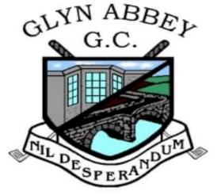
April 21st 2021

GLYN ABBEY GOLF CLUB – WOMEN IN GOLF CHARTER
This Charter is our set of objectives that supports our commitment to develop Ladies, girls and Family golf at Glyn Abbey Golf Club.
We have 9 core commitments outlined below
More women, girls and families playing golf
- Aim to increase the Women’s section by 10 per annum through Wales Golf New2Golf
- Get all tees measured and rated for 9-hole scorecards in 2021
- Continue the Junior Academy and aim to increase membership by 10 in 2021
- Promote Women’s golf by increasing the number of competitions in 2021 from 5 to 11
More females (and young people) in decision making and volunteer roles
- Provide volunteering opportunities for existing female members to volunteer in the 2021 New2Golf scheme
- Establish role descriptors for the main committee positions by the end of 2021
More welcoming and inspiring environment for women, girls and families
- Update our website by the end of 2021 to have more gender-neutral imagery
- Host 3 Family golfing events in 2021 (Red Tee Challenge, Women’s Open Day, Captains Days)
- Communicate promote and encourage the Charter within and beyond Glyn Abbey by posting on our website, social media and local press
We are committed to achieving our pledge and will continue to work collaboratively with our County and Wales Golf to encourage Women and Girls of all ages into the game of golf, nurture those already playing and provide every opportunity for Women to engage in the running and management of the Club.

………………………………………… Charter Champion
Signed Date

